*Full title:* Serum potassium and magnesium levels associated with cardiac arrhythmias

*Short Title*: Phillips: Electrolytes and Clinical Events

Author List:

Correspondence:

Colin T Phillips, MD

Cardiovascular Division, Department of Medicine,

Beth Israel Deaconess Medical Center

330 Brookline Ave.

Boston, MA 02215

ctphilli@bidmc.harvard.edu

Phone: 619 616 6162

Fax: 617 667 9369

*Total Word Count:*

*Journal Subject Codes:* Arrhythmias, Nursing, Quality and Outcomes

**Abstract:**

**Background**: Current potassium and magnesium repletion thresholds applied across the entire intensive care unit (ICU) population are derived from small observational trials and expert opinion with the goal of preventing cardiac arrhythmias. Individualizing repletion thresholds would reduce tasks and cost in the ICU.

**Objective:** To determine if low serum potassium or magnesium levels are associated with an increased risk of cardiac arrhythmias in a large ICU population.

**Design, Setting, and Patients**: Retrospective cohort study of all patients from the Philips ICU database. Between January 200x and December 20xx, 100,xxx patients had 1,xxx,xxx unique potassium draws and 1,xxx,xxx magnesium draws. Potassium levels were categorized in 8 bins (<2.49, 2.50-2.99, 3.00-3.49, 3.50-3.99, 4.00-4.49, 4.50-4.99, 5.00-5.49, >5.5) and serum magnesium levels into 4 bins (<1.49, 1.50-1.99, 2.00-2.49, >2.50).

**Main outcome measures:** Clinical events defined as the administration of an antiarrhythmic drug in the 2 hours prior to the lab draw. Analysis was stratified based on admission diagnosis, ICU day (day 1, day 2, day 3) and the ICU type the patient was admitted to.

**Results**: Rates of clinical events were increased in patients with serum potassium levels of <xx compared to a baseline value of 4.0-4.49. Patients with admission diagnosis of XX were more sensitive to hypokalemia, with increased rates of events in potassium < xx. Likewise, hypomagnesimia was only associated with clinical events at levels below xx.

**Conclusions**: Among a large ICU cohort, serum potassium and magnesium levels had an increased association of cardiac arrhythmias at levels far lower than current threshold guidelines. Patients admitted with the diagnosis of xxx were more sensitive to low levels of potassium.

**Key Words**: Big Data, Electrolyte Imbalances, Arrhythmia, Hypokalemia, Hypomagnesemia

**Background**:

Perturbations in serum potassium and magnesium concentrations are associated with an increased risk of cardiac arrhythmias and sudden cardiac death1-7. Retrospective observational data suggest an increased incidence of ventricular arrhythmias in hypokalemic and hypomagnesemic patients diagnosed with acute myocardial infarction2,8-10. In the outpatient setting, low potassium values are also associated with an increased incidence of sudden cardiac death in patients administered diuretic medications11,12.

In the setting of an acute myocardial infarction or congestive heart failure, many experts recommend a potassium concentration of at least 4.0meq/L (4.0mmol/L) and a magnesium concentration of 2.0meq/L (2.0mmol/L) to limit cardiac arrhythmias2,4,7,13. Extrapolating from these recommendations and other small retrospective studies, potassium and magnesium repletion protocols are often applied across the entire intensive care unit population6,7,12-15.

The clinical efficacy of correcting potassium and magnesium in all ICU patients as currently practiced remains unknown, and is based on trials of patients with myocardial infarction that occurred before the use of early reperfusion strategies and beta-blockade5,14. Although electrolyte repletion to maintain the recommended concentrations continues in all ICUs at non-trivial expense and effort, it is unlikely that a sufficiently large prospective randomized trial will identify the optimal thresholds.  The objective of this study is to test the hypothesis that hypokalemia and hypomagnesemia are associated with clinical arrhythmias well below current repletion thresholds.

**Methods:**

  In this study, we utilized the Philips database to evaluate for an association between potassium and magnesium values and clinical events. The database, developed and maintained by xxx, contains high temporal resolution data from information systems, including bedside monitors, laboratory results, electronic documentation in clinical notes and nursing flow sheets, administrative data. Use of the Philips database for research and quality improvement has been approved by the Institutional Review Boards of the Beth Israel Deaconess Medical Center and the Massachusetts Institute of Technology.

Each serum potassium or magnesium level was considered a unique data point. Potassium levels were separated into 8 bins (<2.49, 2.50-2.99, 3.00-3.49, 3.50-3.99, 4.00-4.49, 4.50-4.99, 5.00-5.49, >5.5) and serum magnesium levels into 4 bins (<1.49, 1.50-1.99, 2.00-2.49, >2.50). For each potassium or magnesium level, the preceding 2 hours were interrogated for a clinical event. Potassium and magnesium were treated independently.

Clinical events were defined as the administration of an antiarrhythmic drug (adenosine, amiodarone, digoxin, diltiazem, esmolol, lidocaine, metoprolol, procainamide, or sotalol). We further corroborated the event by either an increase in heart rate of 30 beats per minute, a change in rhythm recording from sinus or sinus tachycardia to another rhythm, or documentation of a cardioversion. 100 cases were reviewed at the patient level data to confirm the presence of a clinical event.

Separate analysis was performed for admission diagnosis, each of the first 3 days in the ICU as well as for each of the ICU types in the database (medical ICU [MICU], surgical ICU [SICU], coronary care unit [CCU], cardiac surgery recovery unit [CSRU]). Each analysis considers the proportion of cases that experienced a cardiac event and identifies the trend, or lack thereof, using a Mann-Kendall trend test within each day and care unit.

**Results**:

Of 100 patients administered an antiarrhythmic medication and meeting one of the three criteria, all patients had a documented clinical event by individual chart review.

On day 1, xxxx patients were included with a potassium lab and xxxx patients were included with a magnesium lab. These decreased to xxxx (potassium) and xxxx (magnesium) patients on day 2, and xxxx and xxxx patients on day 3.

Potassium and magnesium levels over time regressed to the mean during their hospital stay (Figure 1a and b). During the first 5 days of ICU stays, there is no statistically significant difference among the means. However, variance reduces significantly in potassium.

Analyzing the incidence of clinical cardiac events prior to electrolyte repletion across both magnesium and potassium, after stratifying over admission diagnosis, ICU day, and ICU care unit, a Mann-Kendall trend test found no significant increase in the proportion of cardiac events at the p = 0.01 level.

**Discussion**:

Clinical events in the study population occur at potassium and magnesium levels far below the thresholds for replacement that govern current practice. In this sample of xxxxxxxx subjects we found no correlation between determinations of the serum potassium and magnesium and the frequency of clinical cardiac events prior to electrolyte repletion. Patients who did derive benefit were those below a level of XX and located in a CCU. Patients with potassium levels <2.0 were the only patients with events in the other ICUs.

“Big Data” offers opportunities to elucidate data rich questions such as establishing safe and optimal potassium and magnesium levels for critically ill patients. A prospective randomized controlled trial to address this question would be challenging with regard to patient enrollment because it is likely that physicians and nurses would be reluctant to participate in a study which they would perceive as putting their patients at risk. Interrogating a large clinical database allows us to correlate electrolyte levels with clinical events that occurred in real-world practice to inform the care of future patients. Furthermore, awareness of these results might encourage physicians to participate in a carefully designed study because our observational study demonstrates the very limited risk to patients of exposure to electrolyte levels below the current laboratory ‘low’ value cutoff levels. In another manner of speaking, our purely databased observational study serves as a kind of pilot study establishing the safety of pursuing the issue in future study patients. Even without further study, our results indicate that current practices with regard to the replacement of these particular electrolytes can be modified in ways that should reduce the workflow effort and the costs dedicated to this purpose.

In terms of prior work in this area, a single-center, prospective controlled trial was designed to analyze the effects of targeting potassium repletion to 4.0mmol/L versus 4.5mm/L in a cardiovascular ICU. There was no significant difference in the incidence of atrial fibrillation or atrial flutter in the 910 patients analyzed15.

A large retrospective cohort study of 40,000 patients admitted with myocardial infarction demonstrated that an average post-admission potassium level of less than 3.0meq/L was associated with an increased risk of cardiac arrest and ventricular fibrillation. While the authors recommended liberalizing the potassium threshold to 3.5meq/L from 4.0meq/L, the study was not designed to correlate the event with a specific potassium level and rather was focused on the average admission potassium level5. Reflecting the uncertainty of this practice, the most recent clinical practice guidelines for the management of non-ST-elevation acute coronary syndromes do not mandate specific electrolyte thresholds 16.

Numerous assumptions are made in this analysis, primarily that potassium and magnesium levels do not change in the preceding hour before the electrolyte draw was done and that the value obtained reflects the value at the level of the myocardium. As such, there were no exclusion criteria for patients administered intravenous potassium or magnesium or those treated with medications that alter potassium or magnesium homeostasis or on dialysis/ CVVH during the period of interest. Another assumption is that patients on an antiarrhythmic drug drip at baseline (due to inability to take oral medications, or following an event) will be equally distributed among the bins. These patients will also likely not be included in the analysis since they will not have either a change in heart rate, change in heart rhythm, or have a cardioversion. In addition, the assumption is that administration of an antiarrhythmic drug will not affect serum potassium or magnesium levels significantly within an hour. Finally, the assumption is made that each blood draw represents a true level, and not laboratory error.

Further limitations include the potential to not count patients who died before cardioversion or medication administration could be performed. Additionally, treating magnesium and potassium independently is inherently confounded, since magnesium acts as a cofactor for potassium adsorption from the gastrointestinal tract 6,7.

We encourage others to improve on our methodology and study design, and apply them to other pertinent clinical databases as they become available. We also recommend that other ICUs repeat this analysis to formulate locally relevant practice guidelines. We are providing the code and queries that we used in the Philips database.

In conclusion, (no) correlation exists between determinations of the serum potassium and magnesium and the frequency of clinical cardiovascular events prior to electrolyte repletion.

Purely data-based, observational studies such as this one may serve as virtual pilot studies with respect to the safety of changes in clinical practice that might otherwise not be undertaken due to the caution of clinicians. This kind of observational pilot study could establish whether such caution was justified, or that a carefully designed clinical study could be undertaken with reasonable safety in order to more fully understand the issues and practices involved.

**Acknowledgements:**

This work was helped by the efforts by Kristy Simmons, Yan Kou, Jalal A. Khan, Scott Roset, and Sunil Nair, MD in the 3rd MIT Critical Care Datathon.

Funding sources: xxx

Disclosures:

None**References**:

1. Obeid AI, Verrier RL, Lown B. Influence of glucose, insulin, and potassium on vulnerability to ventricular fibrillation in the canine heart. *Circ Res*. 1978;43:601–608.

2. Kafka H, Langevin L, Armstrong PW. Serum magnesium and potassium in acute myocardial infarction. Influence on ventricular arrhythmias. *Arch Intern Med*. 1987;147:465–469.

3. Gettes LS. Electrolyte abnormalities underlying lethal and ventricular arrhythmias. *Circulation*. 1992;85:I70–6.

4. Macdonald JE, Struthers AD. What is the optimal serum potassium level in cardiovascular patients? *Journal of the American College of Cardiology*. 2004;43:155–161.

5. Goyal A, Spertus JA, Gosch K, Venkitachalam L, Jones PG, Van den Berghe G, Kosiborod M. Serum potassium levels and mortality in acute myocardial infarction. *JAMA*. 2012;307:157–164.

6. Surawicz B. Is hypomagnesemia or magnesium deficiency arrhythmogenic? *Journal of the American College of Cardiology*. 1989;14:1093–1096.

7. Cohn JN, Kowey PR, Whelton PK, Prisant LM. New Guidelines for Potassium Replacement in Clinical Practice. *Arch Intern Med*. 2000;160:2429.

8. Hulting J. In-hospital ventricular fibrillation and its relation to serum potassium. *Acta Med Scand Suppl*. 1981;647:109–116.

9. Nordrehaug JE, Lippe von der G. Hypokalaemia and ventricular fibrillation in acute myocardial infarction. *Br Heart J*. 1983;50:525–529.

10. Schulman M, Narins RG. Hypokalemia and cardiovascular disease. *The American Journal of Cardiology*. 1990;65:4E–9E– discussion 22E–23E.

11. Multiple risk factor intervention trial. Risk factor changes and mortality results. Multiple Risk Factor Intervention Trial Research Group. *JAMA*. 1982;248:1465–1477.

12. Cohen JD, Neaton JD, Prineas RJ, Daniels KA. Diuretics, serum potassium and ventricular arrhythmias in the Multiple Risk Factor Intervention Trial. *The American Journal of Cardiology*. 1987;60:548–554.

13. Couture J, Létourneau A, Dubuc A, Williamson D. Evaluation of an Electrolyte Repletion Protocol for Cardiac Surgery Intensive Care Patients. *CJHP*. 2013;66.

14. Fairley J, Glassford NJ, Zhang L, Bellomo R. Magnesium status and magnesium therapy in critically ill patients: A systematic review. *J Crit Care*. 2015;30:1349–1358.

15. Hoekstra M, Hessels L, Rienstra M, Yeh L, Lansink AO, Vogelzang M, van der Horst ICC, van der Maaten JMAA, Mariani MA, de Smet AMGA, Struys MMRF, Zijlstra F, Nijsten MW. Computer-guided normal-low versus normal-high potassium control after cardiac surgery: No impact on atrial fibrillation or atrial flutter. *American Heart Journal*. 2016;172:45–52.

16. Amsterdam EA, Wenger NK, Brindis RG, Casey DE, Ganiats TG, Holmes DR, Jaffe AS, Jneid H, Kelly RF, Kontos MC, Levine GN, Liebson PR, Mukherjee D, Peterson ED, Sabatine MS, Smalling RW, Zieman SJ, American College of Cardiology, American Heart Association Task Force on Practice Guidelines, Society for Cardiovascular Angiography and Interventions, Society of Thoracic Surgeons, American Association for Clinical Chemistry. 2014 AHA/ACC Guideline for the Management of Patients with Non-ST-Elevation Acute Coronary Syndromes: a report of the American College of Cardiology/American Heart Association Task Force on Practice Guidelines. Journal of the American College of Cardiology. 2014;64:e139–228.

**Figure Legends**:

**Figure 1:** Patient flow chart

**Figure 2:** Trend in a) potassium and b) magnesium values during hospitalization across all ICUs.

**Figure 3:** Binned histograms of the a) potassium and b) magnesium values during hospital days 1, 2, and 3. The proportion of cardiovascular events for each bin within all ICUs, and label the absolute number of patients that fell into each bin as a call out. For example, in Figure 2a’s second row and first column, we show that there were 778 MICU patients with a serum potassium level >4.5 measured on ICU day 1. Of those, approximately 20% experienced a clinical cardiac event.

**Figures:**

Flow chart:

1xx,xxx patients

1,xxx,xxx potassium and 1,xxx,xxx magnesium draws

Previous 2 hours

Xxx clinical events defined as antiarhythmic medication and change in rhythm, increase in heart rate by 30, or documented cardioversion

**FIGURE 2a**

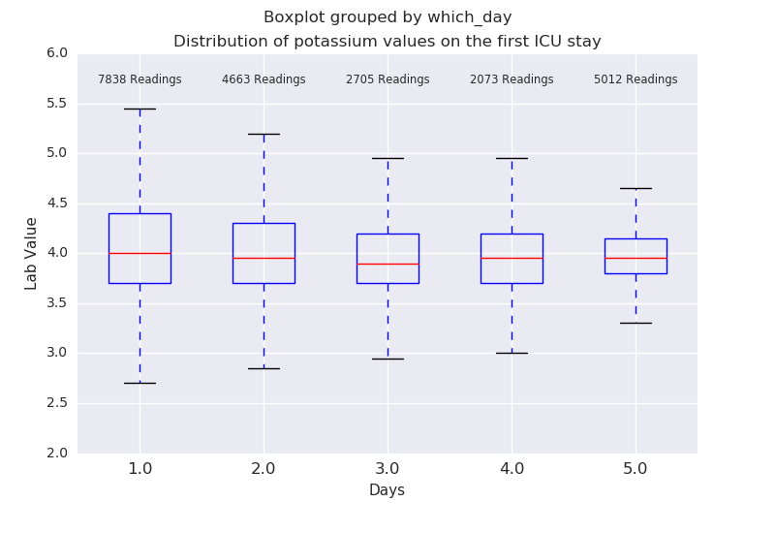

**FIGURE 1b**

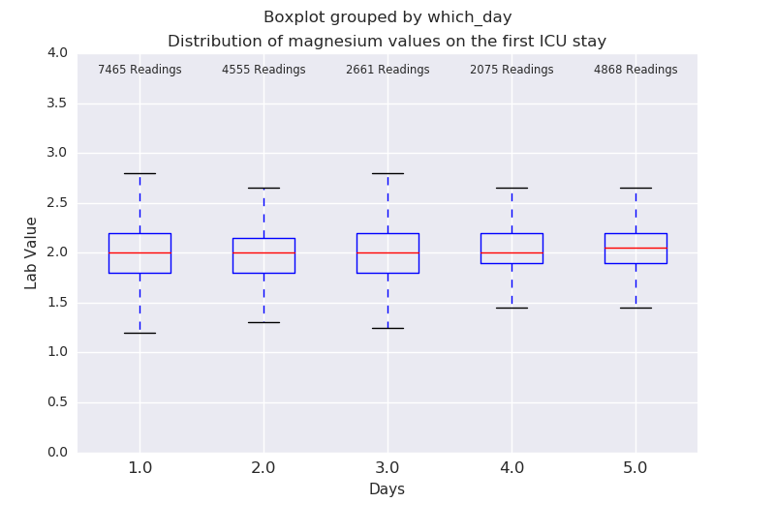

**FIGURE 2a**

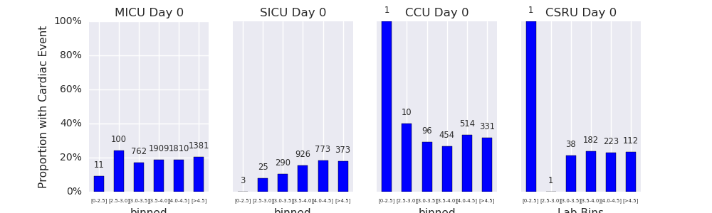

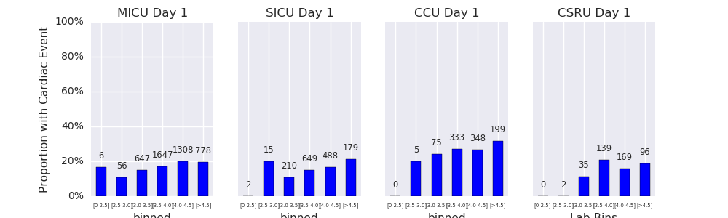

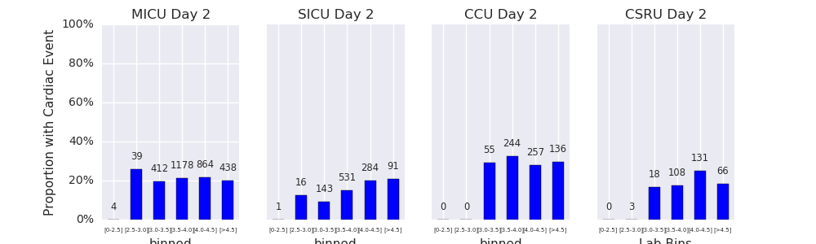

**FIGURE 2b**

